OPERATING SYSTEMS AND SYSTEMS PROGRAMMING

Sec:- 2

Name:- Sai Sowseelya Vedula
RollNo:- 2520030260

Pipes
- Create FIFO

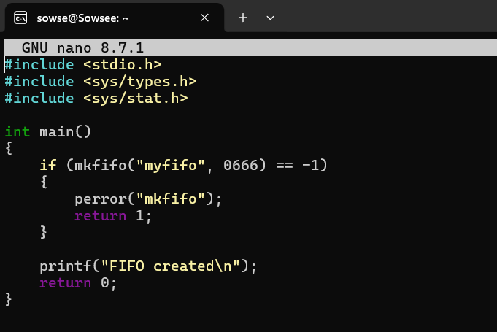
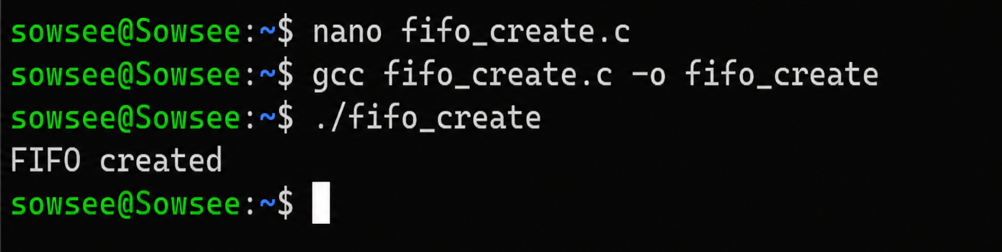

- Read from FIFO

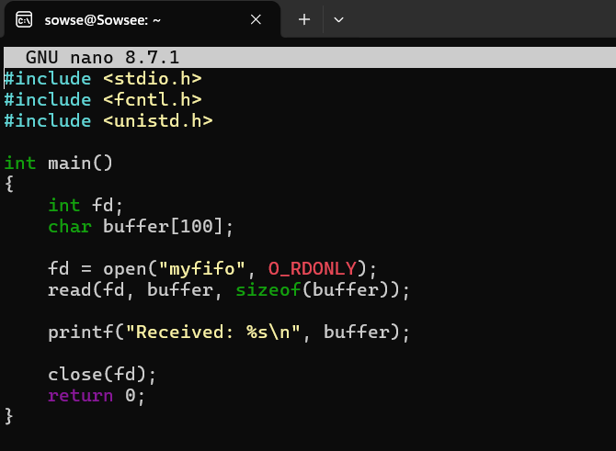
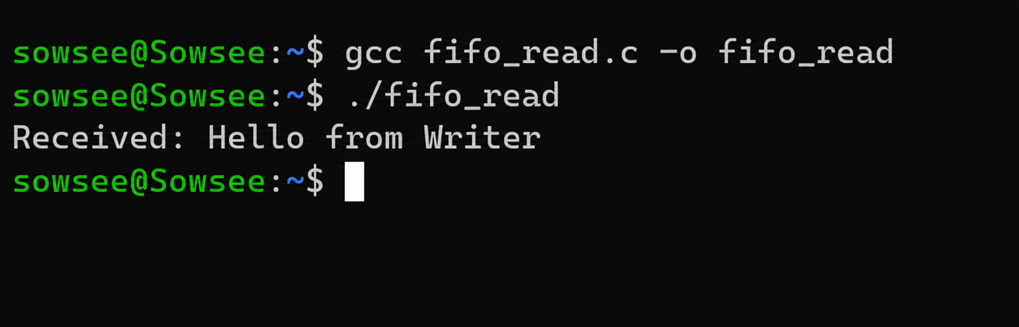

- Write to FIFO
